1. Create a bash script to **check if a directory is available or not**.



Steps: Task 1:

#!/bin/bash

echo "Enter directory path:"

read dir

if [ -d "$dir" ]; then

echo "Directory exists."

else

echo "Directory does not exist."

Fi

1. Create a bash script to **create multiple files**.

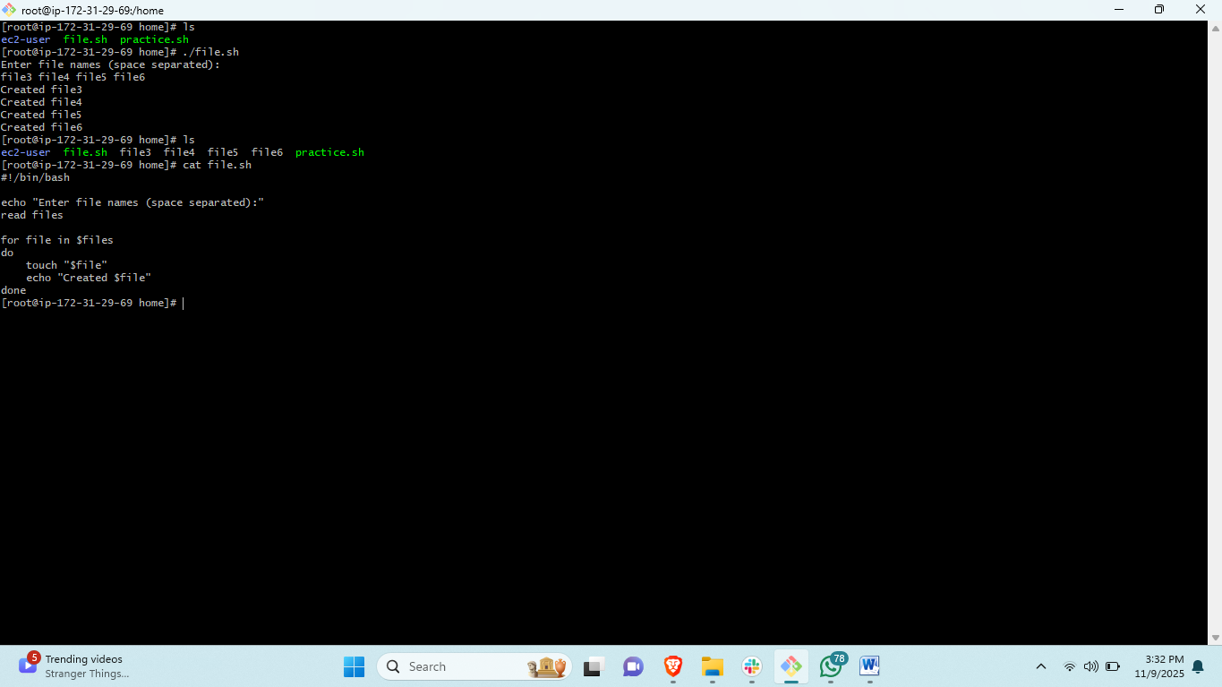

1. Create a bash script to **take a backup of a directory**.

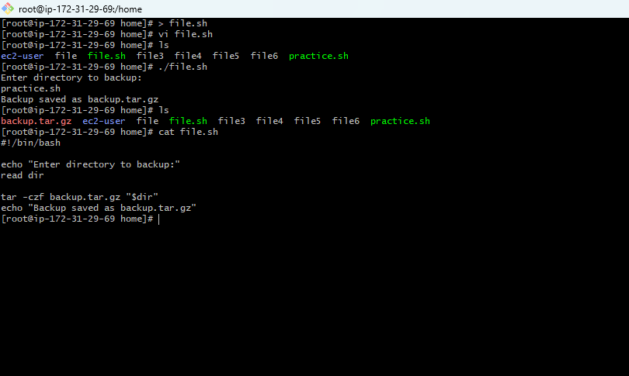

1. Create a bash script to **install Nginx on an EC2 server**.

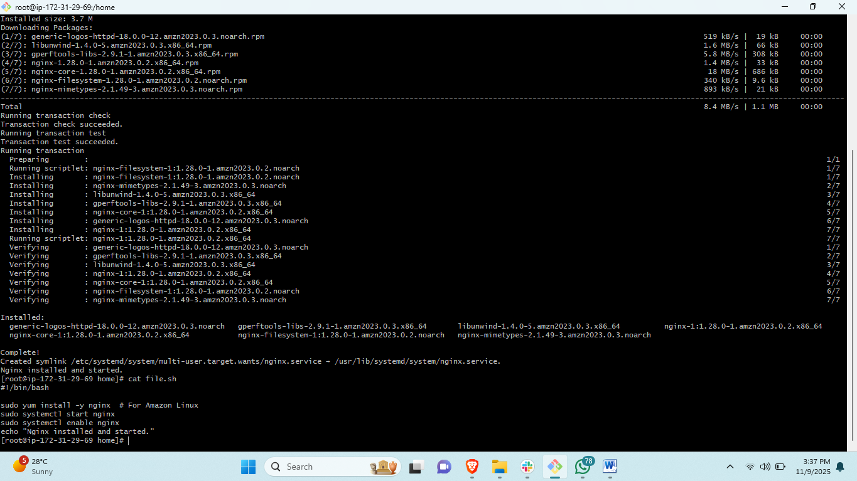

1. Create a bash script to **install Apache Tomcat on an EC2 server**.

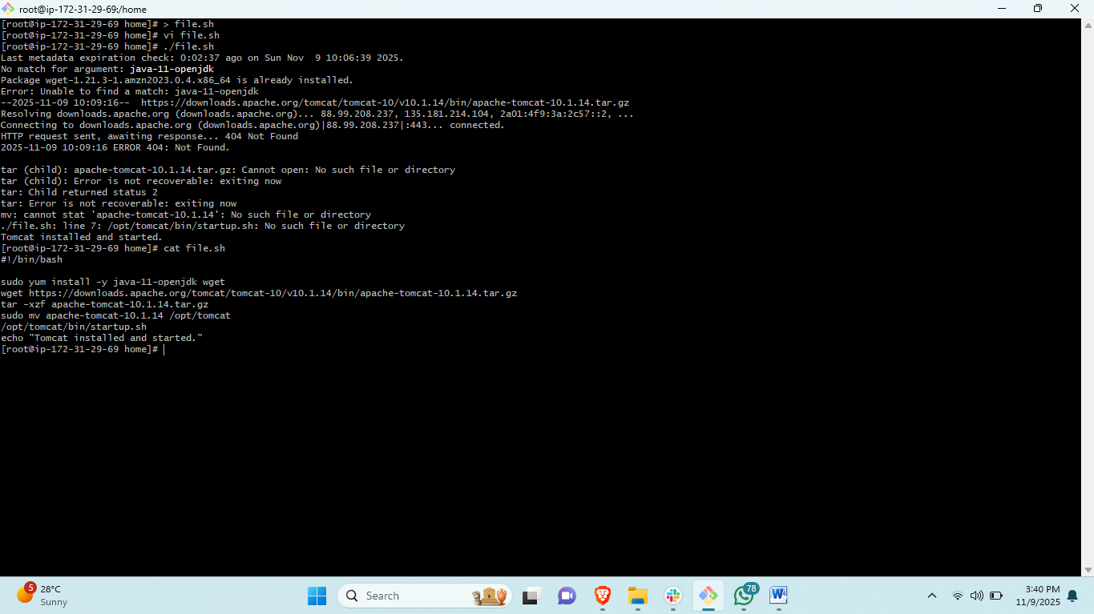

1. Create a bash script to **check if the Nginx service is running**, if not running then script should start the service.

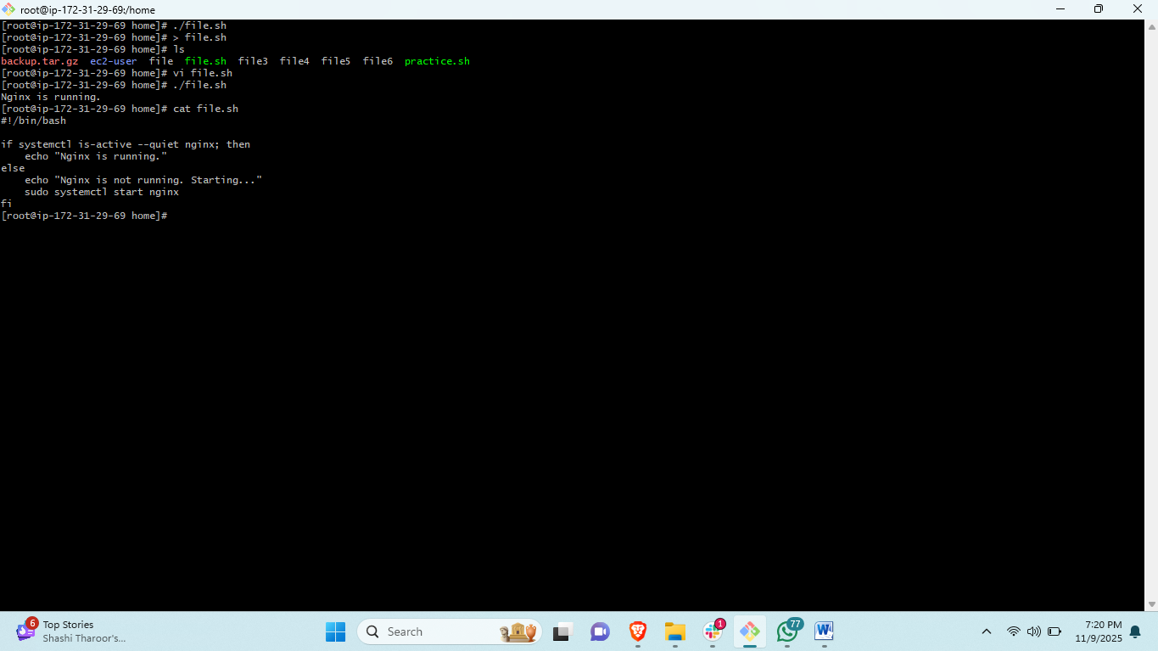

1. Create a bash script for a **calculator**.

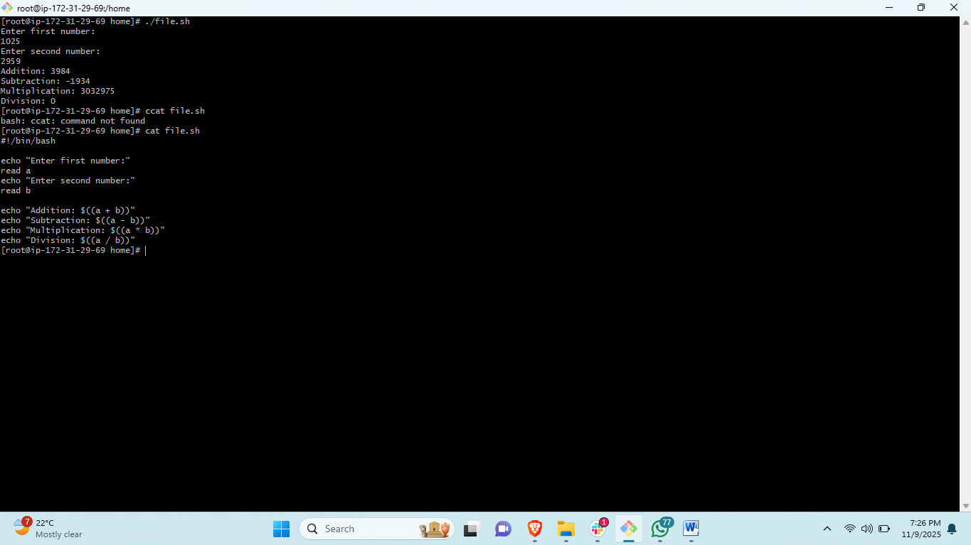

1. Create a bash script to **check if a directory exists**, if not then create a directory.

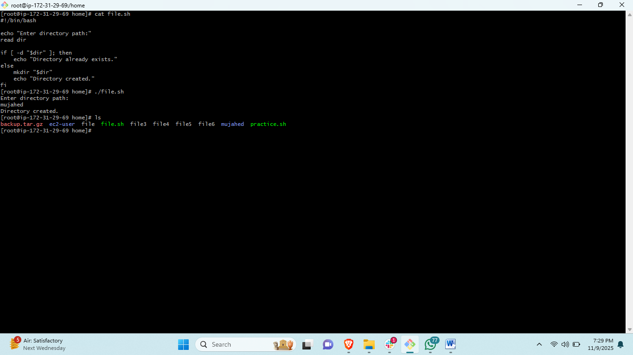

1. Create a bash script to **delete the last 3 lines of a file**.

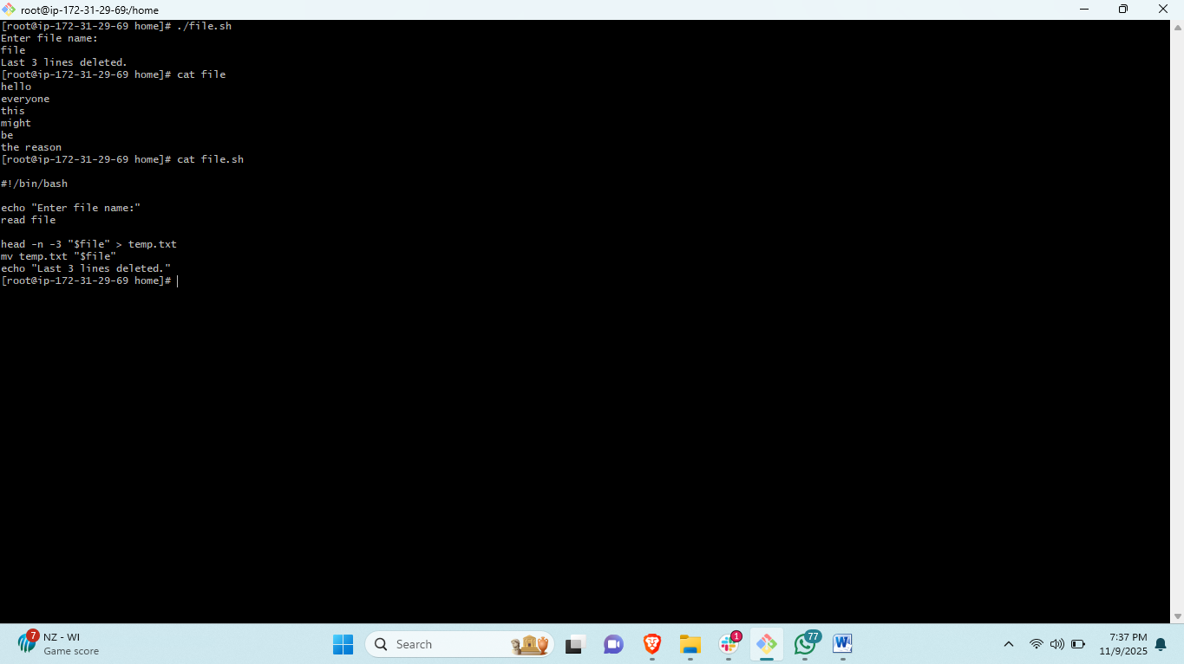

1. Bash script to monitor cpu and if it is more than 80% then send email notification.

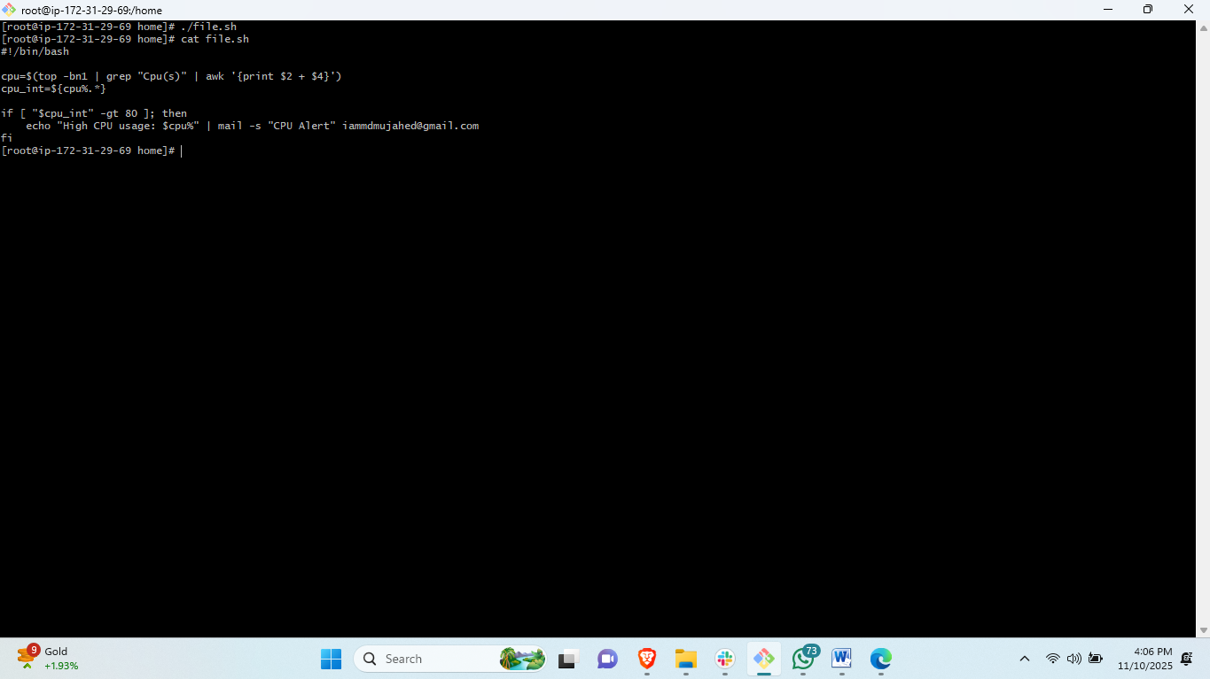

1. Bash script to monitor disk space and if it is more than 80% then send email notification.

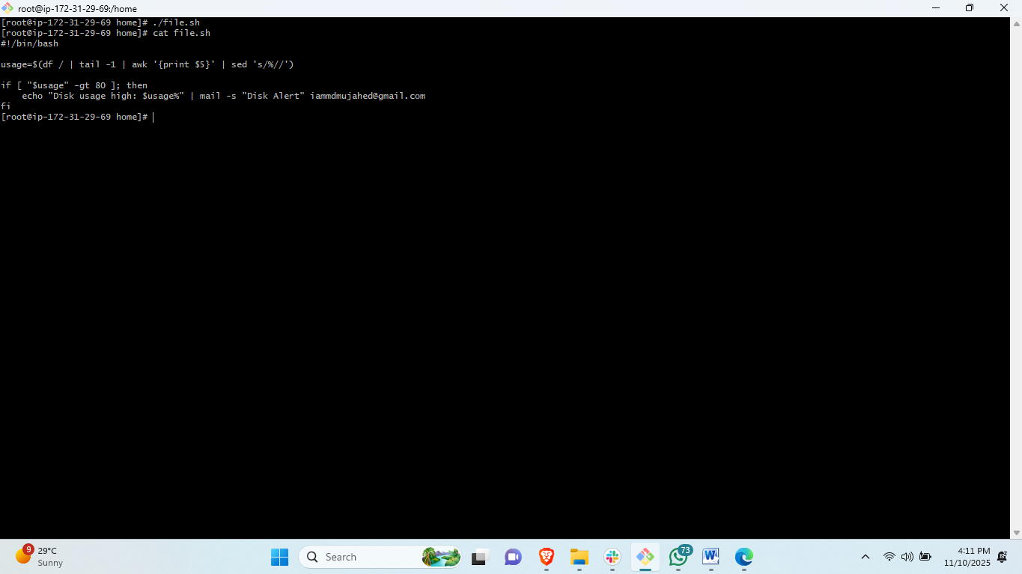

1. Bash script to monitor memory and if it is more than 80% then send email notification.

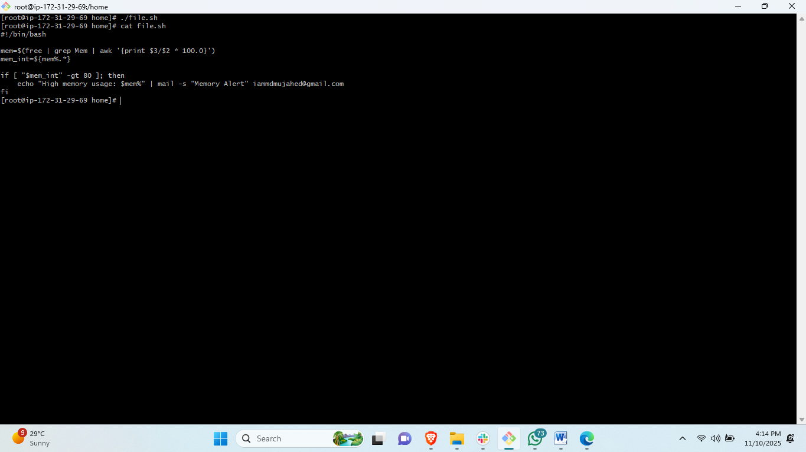

**Exercise: Crontab Entries**

1. April 5th Midnight



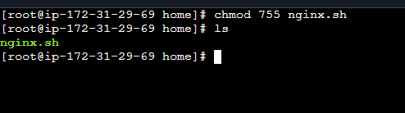

1. 5th of Every November, January, June **if it is a Thursday**

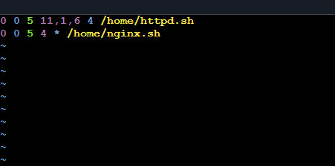

1. At **05 and 27th minutes** of **9, 10, 11** hours every day

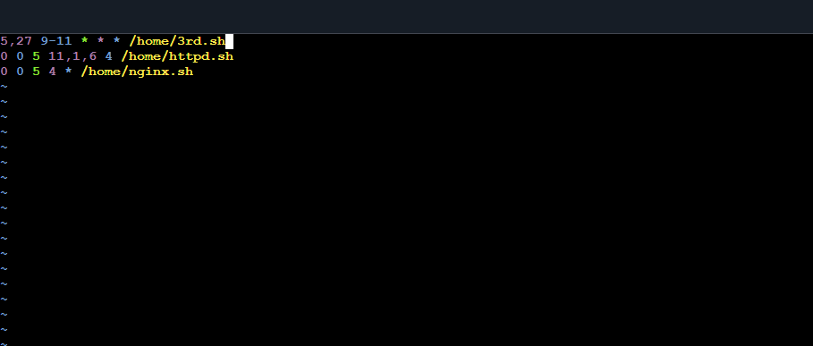

1. **34 minutes** of **9th hour** on **15th August**

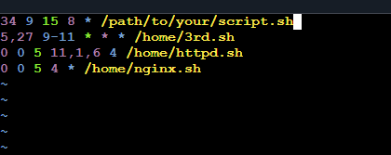

1. Every midnight

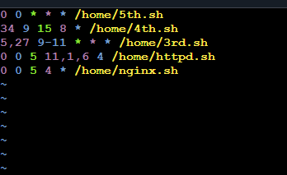

1. Every Weekend (**Saturday night 11:59 PM**)

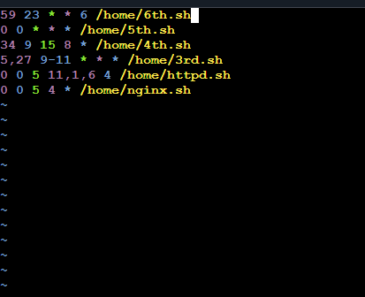

1. After every reboot

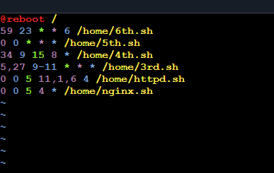

Reboot to root directory